**Tentative title:** Middle-Aged Mozart

**Name and course info:** Natalie LaRowe, DH 110 Spring 2022

**Description about the project how you want to contribute with your UX design:**

Something I’ve learned from my father since he retired this past year is that it’s never too late to explore new hobbies. Since retiring, he and many of his friends have been committed to trying new things that they never seemed to have the time for before, and above all else, they’ve committed to never stop learning. A common hobby that my father and many of his friends are interested in learning is playing music, specifically the piano since it is fairly beginner-friendly. I’ve chosen to dedicate my project to finding a useful and enjoyable app which can help people in their same situation in their endeavors to become the next middle-aged Mozart.

In this assignment I will evaluate using the *10 usability heuristics* and *severity ratings* two potential apps that I have found which contribute to these goals. With this evaluation and suggested improvements, the apps may become more comprehensive and user-friendly for beginners learning piano which will lead to less frustration while learning and overall an increased desire and motivation to learn. The first app I found, Music Tutor, allows users to review and quiz themselves on notes in sheet music, both by name and by location on piano keys. The second app, Ultimate Guitar: Chords and Tabs is both an app and a website where users can look up chords to their favorite songs, learn what the chords look like on piano keys, understand when to play the chords in relation to the words of the song, and more.

0 - no issue

1 - cosmetic issue, resolve if there is time

2 - minor usability issue, app can launch without issue being resolved but improvement of this issue would improve the app noticeably

3 - major usability issue, top priority, important to fix

**Screenshot of web/app**

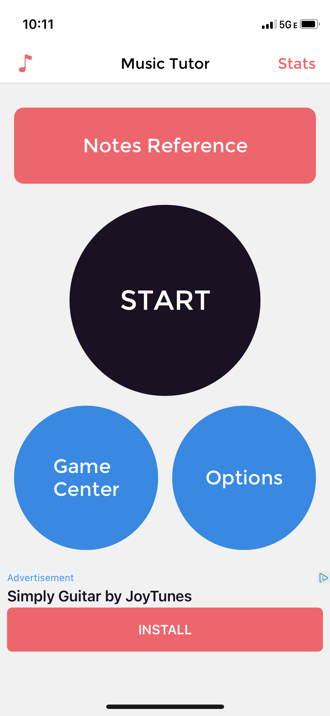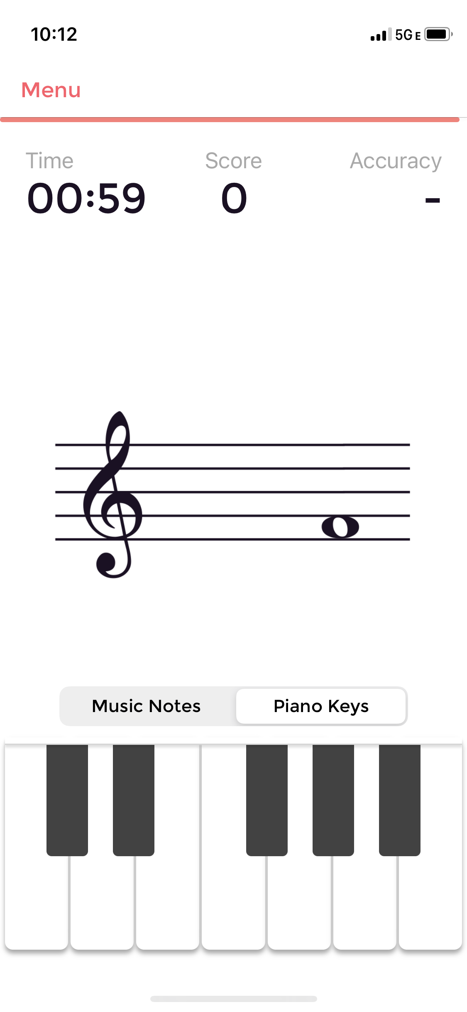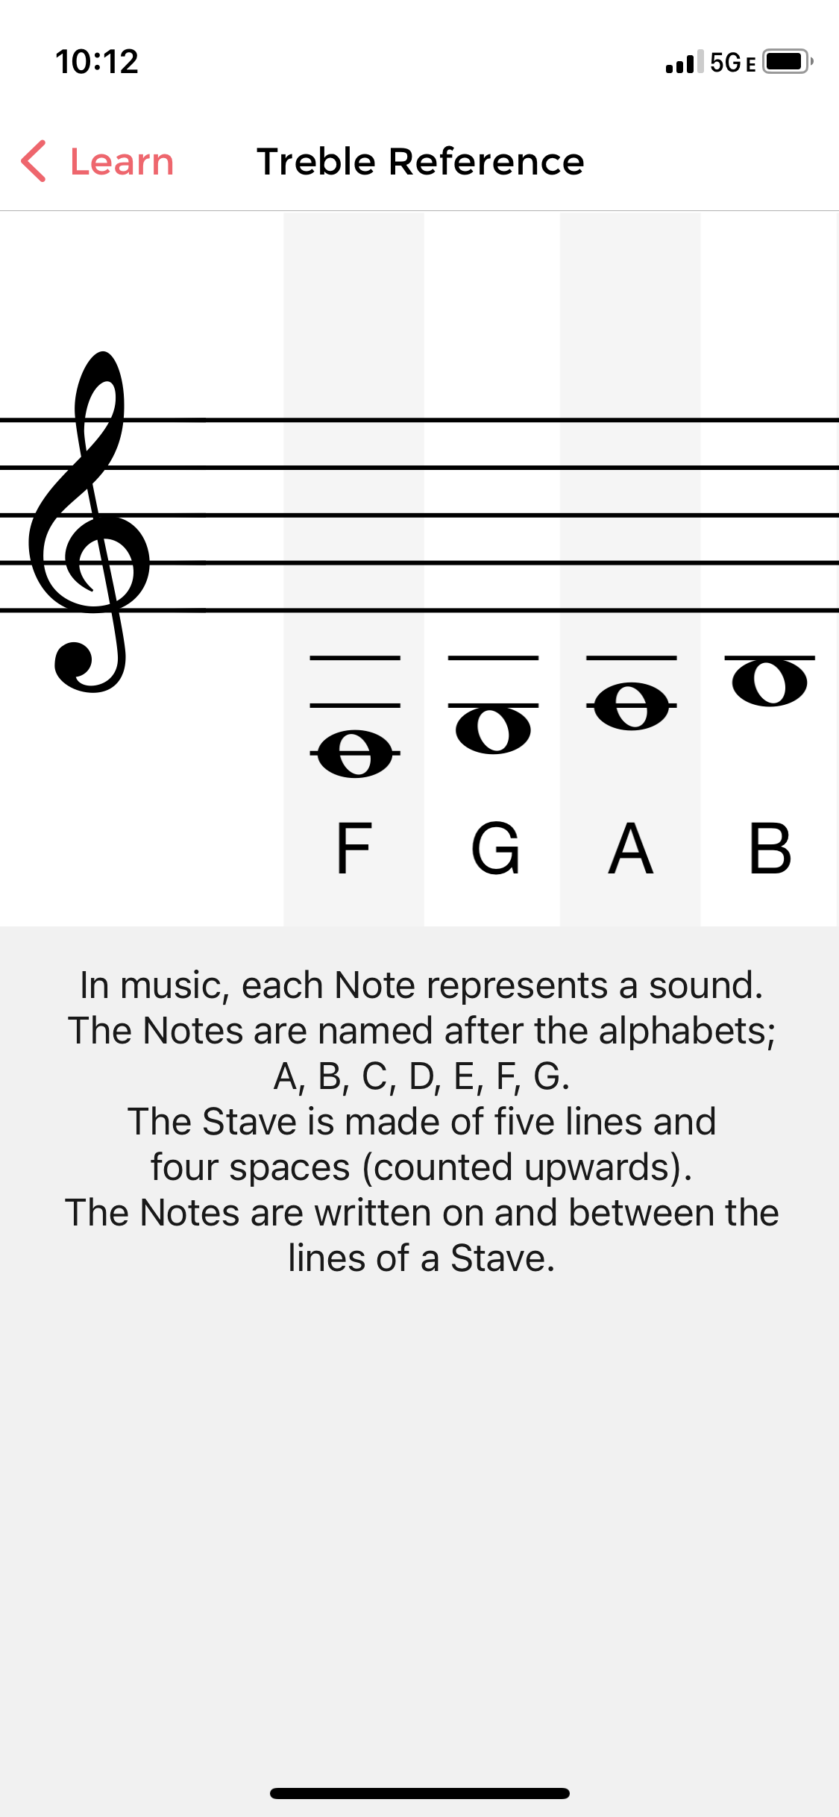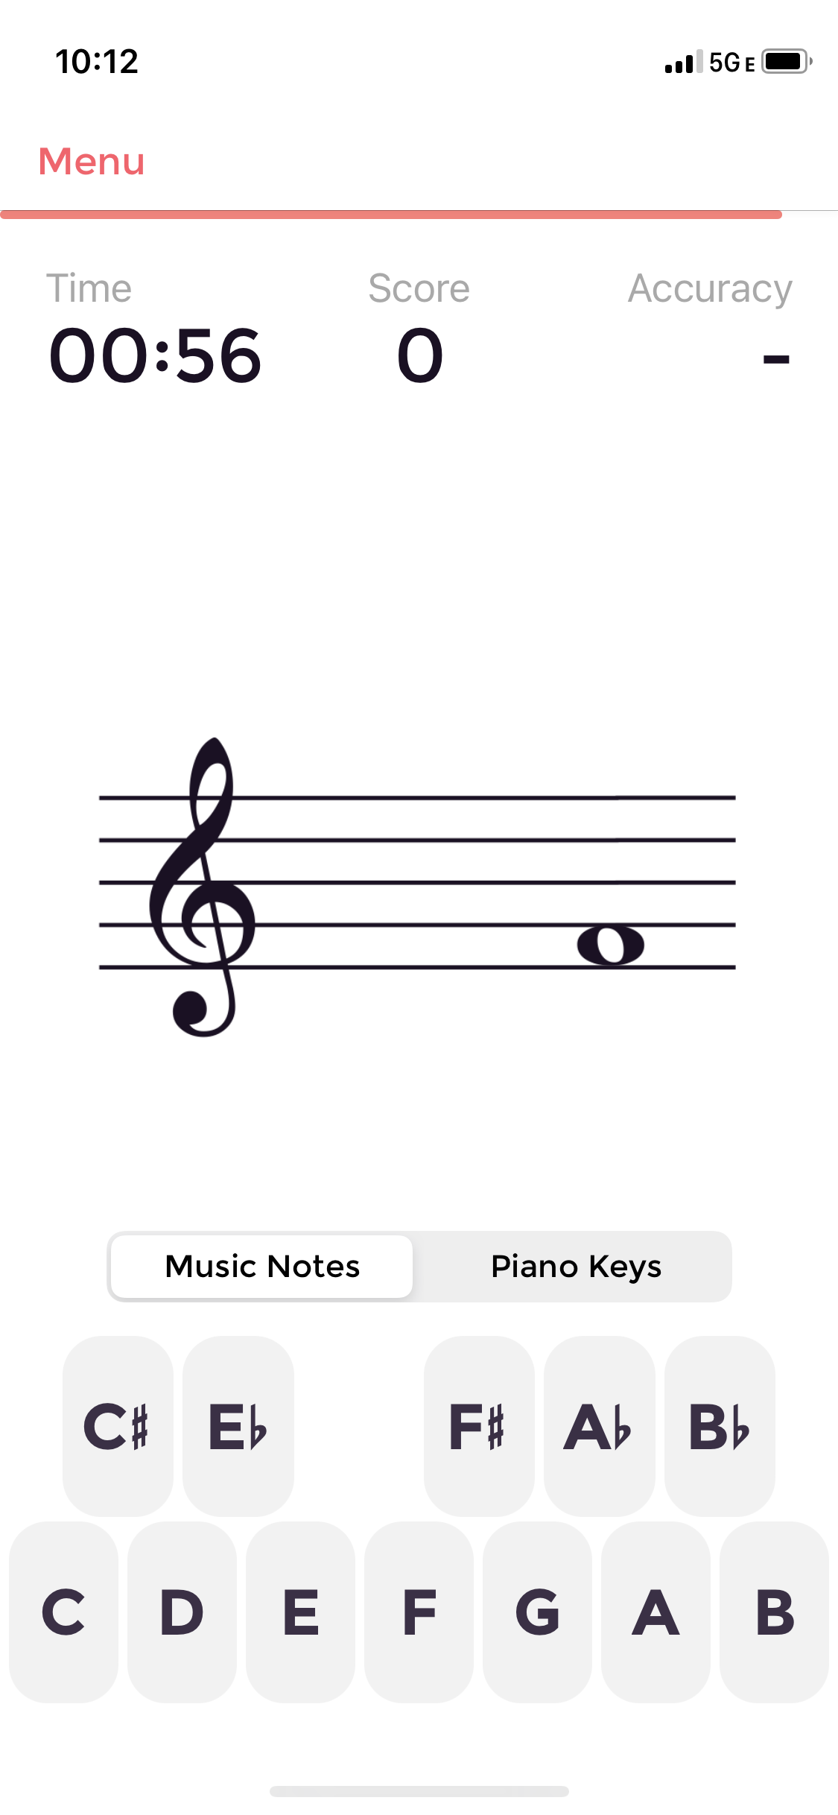

**URL to app** (clickable to launch website) <https://musictutorapp.com/>

**Background info:** This app is designed to allow users a place to learn and practice sight reading with sheet music through testing their knowledge of music notes. Users will launch a practice session and be given a set amount of time to correctly identify as many notes as possible. After the time is complete, users will be given an opportunity to review their mistakes.

**Overall evaluation of website:** This app is designed for someone who already has some familiarity with sheet music and notes, but wants to review and improve by practicing. The app could be useful for improving knowledge of sheet music, but does not offer any options to learn and play songs. For beginners who are interested in having some kind of quantifiable result quickly, this app would likely be discouraging to them as it is more theory-based than performance-based.

Heuristic evaluation:

**Visibility of System Status**

Allows users to see what is going on with the system and confirm that the system is working as desired.

| Severity | Comments/critiques | Proposed improvement |
| --- | --- | --- |
| 1 | There is no loading bar when switching to another section of the app, so if the app is working slowly the user will not know if their action is loading or if the program is malfunctioning | Add a loading bar at the bottom of the screen when toggling between pages so that users can see the status of their action |
| 0 | Users are clearly shown which page they are on at the top of the screen | No proposals |

**Match between system and the real world**

Concepts and language of the system are familiar and relevant to the intended user.

| Severity | Comments/critiques | Proposed improvement |
| --- | --- | --- |
| 3 | Uses terms such as “treble”, “bass”, and “alto” without explaining what the differences are and what significance each has | Include a page which defines musical terms such as “treble”, “bass”, and “alto” or allow these words to be hyperlinked with a pop-up definition that appears over the word when the user hovers over it |
| 0 | In the “notes reference” section, users are introduced to the terms used in a piece of sheet music such as “note”, note names, and “stave” | No proposals |

**User control and freedom**

Gives users the freedom and control to engage with the system, specifically having the ability to undo and redo actions.

| Severity | Comments/critiques | Proposed improvement |
| --- | --- | --- |
| 0 | There is a “back” arrow for users to see which page they were previously viewing and go back to that page | No proposals |

**Consistency and standards**

Utilizes basic well-known conventions and keep symbols and language consistent across the interface.

| Severity | Comments/critiques | Proposed improvement |
| --- | --- | --- |
| 1 | There is no simple “menu” from which to choose pages to navigate to. Rather, users have to choose differently-shaped buttons with the titles that indicate the page they want to go to | Offer a concise, simple menu option in addition to the buttons which direct the user to various pages |
| 0 | There is a clear and large circular “start” button on the main page which launches the practice session, and a clear and large “options” button on the main page which launches the settings | No proposal |
| 0 | When settings are altered to use different note names or default clefs (treble, bass, alto) the practice session and explanations of missed notes reflect these changes in symbols and language | No proposal |

**Error prevention**

Detecting potential errors and preventing them by interface design or notifying the user.

| Severity | Comments/critiques | Proposed improvement |
| --- | --- | --- |
| 3 | When a user clicks “start”, the practice session and timer immediately launch without warning the user to prepare that the timer will be starting | Add a pop-up confirming that the timer will start as soon as “start” is selected, or add a countdown once the user has navigated to the practice session (3, 2, 1 then the timer starts) |
| 0 | While in a practice session, if the user selects “menu”, they are met with a pop-up message notifying them that their progress will be lost and asking them to confirm to end the practice session | No proposal |

**Recognition rather than recall**

Giving users options to recognize rather than asking them to draw from memory.

| Severity | Comments/critiques | Proposed improvement |
| --- | --- | --- |
| 0 | Users can select from available note name options or clef options | No proposal |
| 0 | Users are able to select the name of the note or the key on the piano corresponding to the note being shown to them in the practice session, rather than recalling from memory and typing it in | No proposal |

**Flexibility and efficiency of use**

Creating the system to be flexible so that it is efficient for all levels of user proficiency.

| Severity | Comments/critiques | Proposed improvement |
| --- | --- | --- |
| 3 | No option to select the level of experience or difficulty | In settings or upon startup, allow users to select if they are a beginner, proficient, or expert and offer more informational resources to beginners or proposed settings for each proficiency level |
| 0 | The app offers the option for users to toggle on/off sharp and flat notes, sounds of notes, range of notes they will be quizzed on, and duration of practice time | No proposals |

**Aesthetic and minimalist design**

Ensuring that only necessary information is displayed and not much extra is present to overwhelm the user.

| Severity | Comments/critiques | Proposed improvement |
| --- | --- | --- |
| 0 | Only necessary buttons such as “start”, “options”, and “notes reference” are presented to users on the main page | No proposals |
| 0 | Practice page only includes the necessary and useful information such as notes, time, score, accuracy, and the options to choose between names of notes or piano keys | No proposals |

**Help users recognize, diagnose, and recover from errors**

Notifies users of errors in a clear, gentle way while also guiding them toward potential solutions.

| Severity | Comments/critiques | Proposed improvement |
| --- | --- | --- |
| 0 | The system is designed so that users cannot run into system errors | No proposals |
| 2 | After a practice session, users are given the option to review the notes they missed and see their accuracy and scores on a chart compared to previous practice sessions. After viewing this information there is no guidance on what to do next | If accuracy is within a certain (low) range, suggest that the user review the “notes reference” page before practicing again and offer a button to take them to that page |

**Help and documentation**

Help is easily accessible and language is easy to understand for users requiring more assistance with finding solutions.

| Severity | Comments/critiques | Proposed improvement |
| --- | --- | --- |
| 3 | No help/documentation option | Include a user documentation or help page in the “options” or music note menu |
| 1 | There is a “contact us” option in the music note menu which takes users to an email draft | Make “contact us” option more easy to find by making it an option on the main menu |

**Screenshot of web/app**

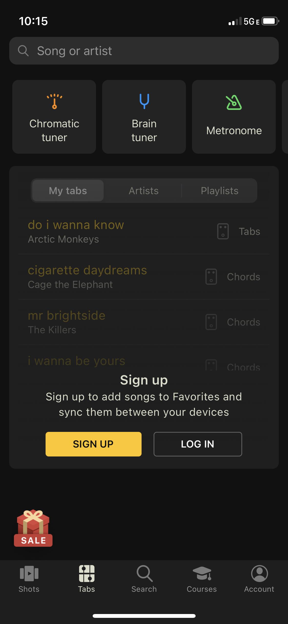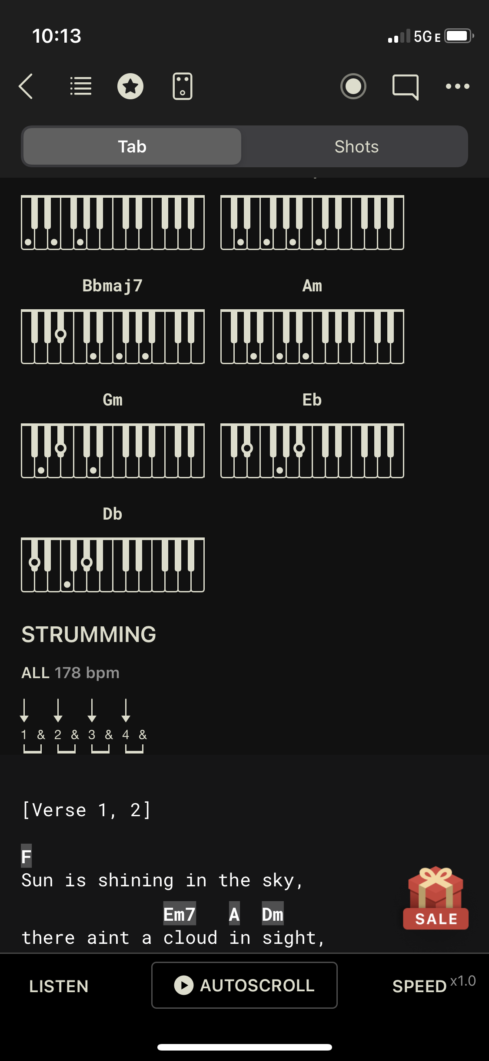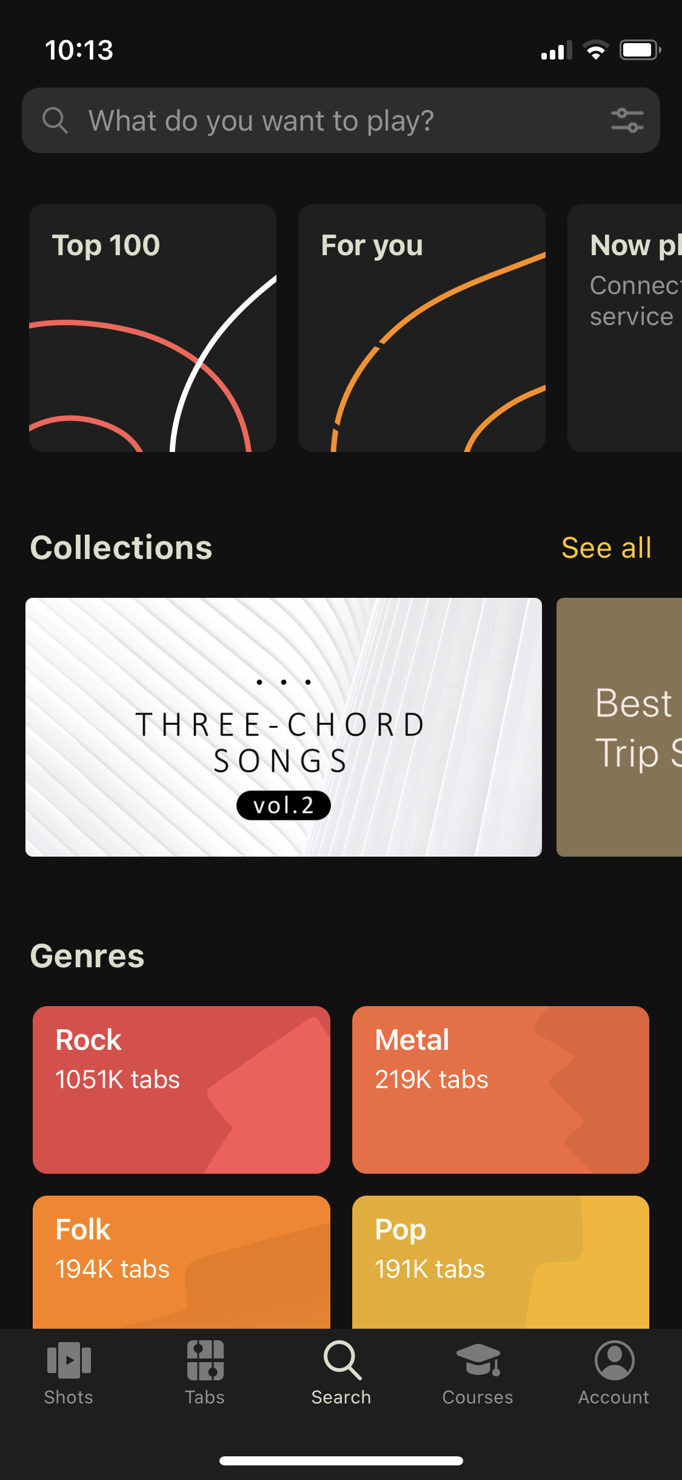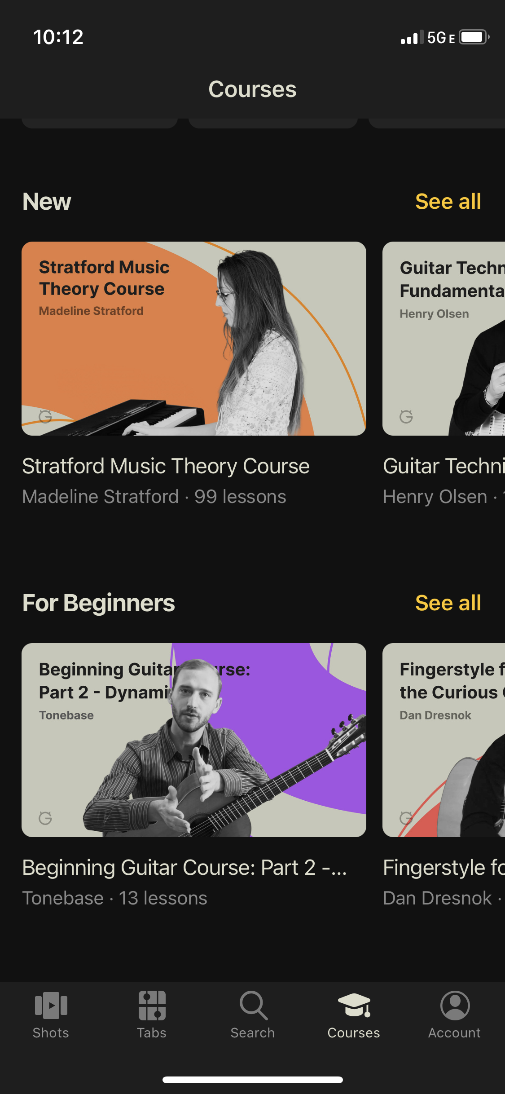

**URL to app (clickable to launch website):** <https://www.ultimate-guitar.com>

**Brief info about website:** Users can search and find chords, tabs, and lyrics to songs that have been uploaded by other users. The app also has the capability to show images of what each chord looks like on your instrument, so that you can learn to play songs that you search.

**Overall evaluation of website:** This app is useful for users of all ages and proficiency levels who want to learn how to play chords or certain songs on a multitude of instruments. The app was clearly designed for guitar players, but some features can be edited to cater to piano players. The app may seem overwhelming to beginners but ultimately all of the information available can be useful to users of all experience levels.

**Heuristic evaluation:**

**Visibility of System Status**

Allows users to see what is going on with the system and confirm that the system is working as desired.

| Severity | Comments/critiques | Proposed improvement |
| --- | --- | --- |
| 0 | There is a loading circle which pops up anytime a new page takes more than a moment to load | No proposal |
| 1 | Side bar while scrolling indicates how far along in a song a user is, but the side bar only shows up while in the act of scrolling | Make side bar always visible so that users can see how far along in a song or chord chart they are |

**Match between system and the real world**

Concepts and language of the system are familiar and relevant to the intended user.

| Severity | Comments/critiques | Proposed improvement |
| --- | --- | --- |
| 0 | Familiar terms used like “chords”, “genres”, “courses”, “account” | No proposal |
| 1 | Uses the term “shots” to designate the space where users have uploaded videos of them playing certain tabs, which may not be intuitive | Rename “shots” to something more intuitive like “videos” |

**User control and freedom**

Gives users the freedom and control to engage with the system, specifically having the ability to undo and redo actions.

| Severity | Comments/critiques | Proposed improvement |
| --- | --- | --- |
| 0 | Users are able to choose which song tabs they’d like to view (uploaded from multiple users), there are clear “back” buttons in the top left corner of the app | No proposal |
| 0 | Upon launch, users are encouraged to select preferences to customize the app for them and these preferences can be retroactively changed in settings | No proposal |
| 2 | No search history of previously searched songs and chords | Include a search history when typing songs into a search bar |
| 0 | Includes recently opened tabs when typing in search bar so users can go back to previously visited pages easily | No proposal |

**Consistency and standards**

Utilizes basic well-known conventions and keeps symbols and language consistent across the interface.

| Severity | Comments/critiques | Proposed improvement |
| --- | --- | --- |
| 0 | Search tab has a magnifying glass icon and the term “search”, Courses tab as a graduation cap icon, and tabs are mostly structured in the same format (titled “chords”, organized by verse, chorus, and bridge) | No proposal |

**Error prevention**

Detecting potential errors and preventing them by interface design or notifying the user.

| Severity | Comments/critiques | Proposed improvement |
| --- | --- | --- |
| 0 | When navigating away from the “edit tabs” page without saving, there is a pop-up notification saying “you haven’t saved your changes. Are you sure you want to continue without saving?” | No proposal |
| 2 | If accidental changes are made to a tab and the user presses “save”, there is no pop-up confirming that the user wants to save in order to prevent accidental changes | Offer a “confirm changes” pop-up after pressing “save” and exiting the edit screen |

**Recognition rather than recall**

Giving users options to recognize rather than asking them to draw from memory.

| Severity | Comments/critiques | Proposed improvement |
| --- | --- | --- |
| 0 | When starting the app, users are given the option to select between music genres and recommended songs they may like rather than having to think of all songs on their own | No proposal |
| 0 | On the search page, users can type in the name of the song they want tabs for or they can browse by genre or category on the same page | No proposal |

**Flexibility and efficiency of use**

Creating the system to be flexible so that it is efficient for all levels of user proficiency.

| Severity | Comments/critiques | Proposed improvement |
| --- | --- | --- |
| 0 | Upon startup, users are able to customize their level of experience, preferred instrument, and how many hours per week they’d like to practice | No proposal |
| 0 | In settings, users are able to customize their experience level in settings>preferences | No proposal |

**Aesthetic and minimalist design**

Ensuring that only necessary information is displayed and not much extra is present to overwhelm the user.

| Severity | Comments/critiques | Proposed improvement |
| --- | --- | --- |
| 3 | Lots of colors, information, and icons on each page of the app. Can be overwhelming or difficult to know where to look for specific things | Simplify each page by using drop-down options rather than presenting all information on one page |
| 0 | When searching a song, multiple tab options are proposed to the user where they can choose which tab to use based on the star ratings shown next to the song title. There is also an icon indicating when a tab requires a “pro” subscription to access | No proposal |

**Help users recognize, diagnose, and recover from errors**

Notifies users of errors in a clear, gentle way while also guiding them toward potential solutions.

| Severity | Comments/critiques | Proposed improvement |
| --- | --- | --- |
| 1 | When incorrect username is inputted in login, a pop-up notification says “incorrect username” in red text and bold font | Red text may make users feel discouraged or frustrated by their errors, make the error message more friendly or use a different color text like blue or green |
| 1 | When incorrect password is inputted in login, a pop-up notification says “incorrect password” in red text and bold font | Red text may make users feel discouraged or frustrated by their errors, make the error message more friendly or use a different color text like blue or green |
| 2 | When incorrect username and password are inputted, the pop-up message only says “incorrect username” and leaves both the incorrect username and incorrect password as entered originally | Create a message that says “incorrect username and password” and automatically clear the input box where the incorrect information was inputted |

**Help and documentation**

Help is easily accessible and language is easy to understand for users requiring more assistance with finding solutions.

| Severity | Comments/critiques | Proposed improvement |
| --- | --- | --- |
| 3 | No clear help document explaining the details of the app and how each function should work | Include a help document in settings to give an overview for those who want to learn about all the capabilities of the app at once |
| 0 | Question and answers document available (FAQ) in settings with a search bar and an option to send a message | No proposal |

**Resources:**

Senior Stories, Joy Hsieh <https://github.com/JoyHsieh/DH110-JoyHsieh-Assignment01/blob/main/README.md>

San Jose Resources, Lillian Nguyen <https://github.com/lilliannguyen97/DH150/tree/master/Assignments/A01>

How to Prioritize Usability Problems <https://www.userfocus.co.uk/articles/prioritise.html>

Severity Ratings for Usability Problems <https://www.nngroup.com/articles/how-to-rate-the-severity-of-usability-problems/>

Heuristic Evaluation: How to Conduct a Heuristic Evaluation <https://www.interaction-design.org/literature/article/heuristic-evaluation-how-to-conduct-a-heuristic-evaluation>

10 tips on how to conduct a perfect Heuristic evaluation <https://medium.muz.li/10-tips-on-how-to-conduct-a-perfect-heuristic-evaluation-ae5f8f4b3257>